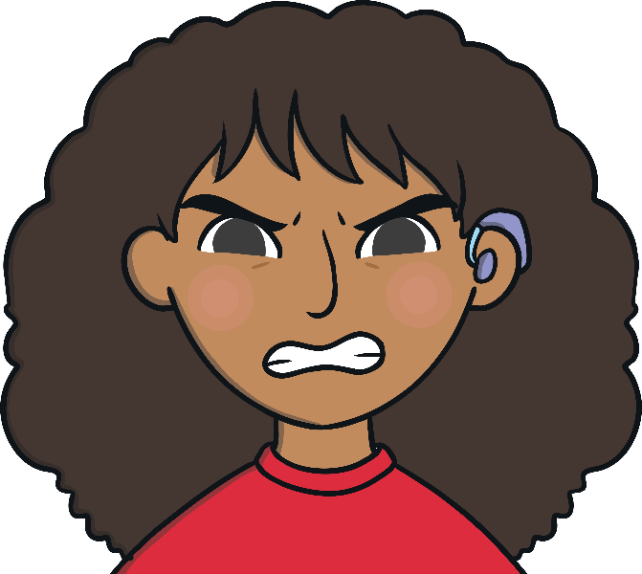

Sometimes, I feel frustrated.

When I am feeling frustrated, I feel cross and annoyed. Feeling frustrated is not a good feeling but we all feel frustrated sometimes.

I might feel frustrated when I cannot complete my schoolwork at home, when I want to go and play with my friends or visit my family.

When I feel frustrated, I need to tell my parents/carers (delete as appropriate) how   
I feel.

I can take a deep breath and say ‘I feel frustrated’ then my parents/carers (delete as appropriate) will know how I am feeling.

My parents/carers (delete as appropriate) will help me to make a good choice. This could be telling me to:

Take 10 deep breaths

Count to 20

Talk to someone or draw how I feel

Have a drink of water

Have a break before going back to the task

I will try and tell my parents/carers (delete as appropriate) when I am feeling frustrated.

This will make my parents/carers (delete as appropriate) happy.

There are four seasons each year, autumn, winter, spring and summer.

seasons